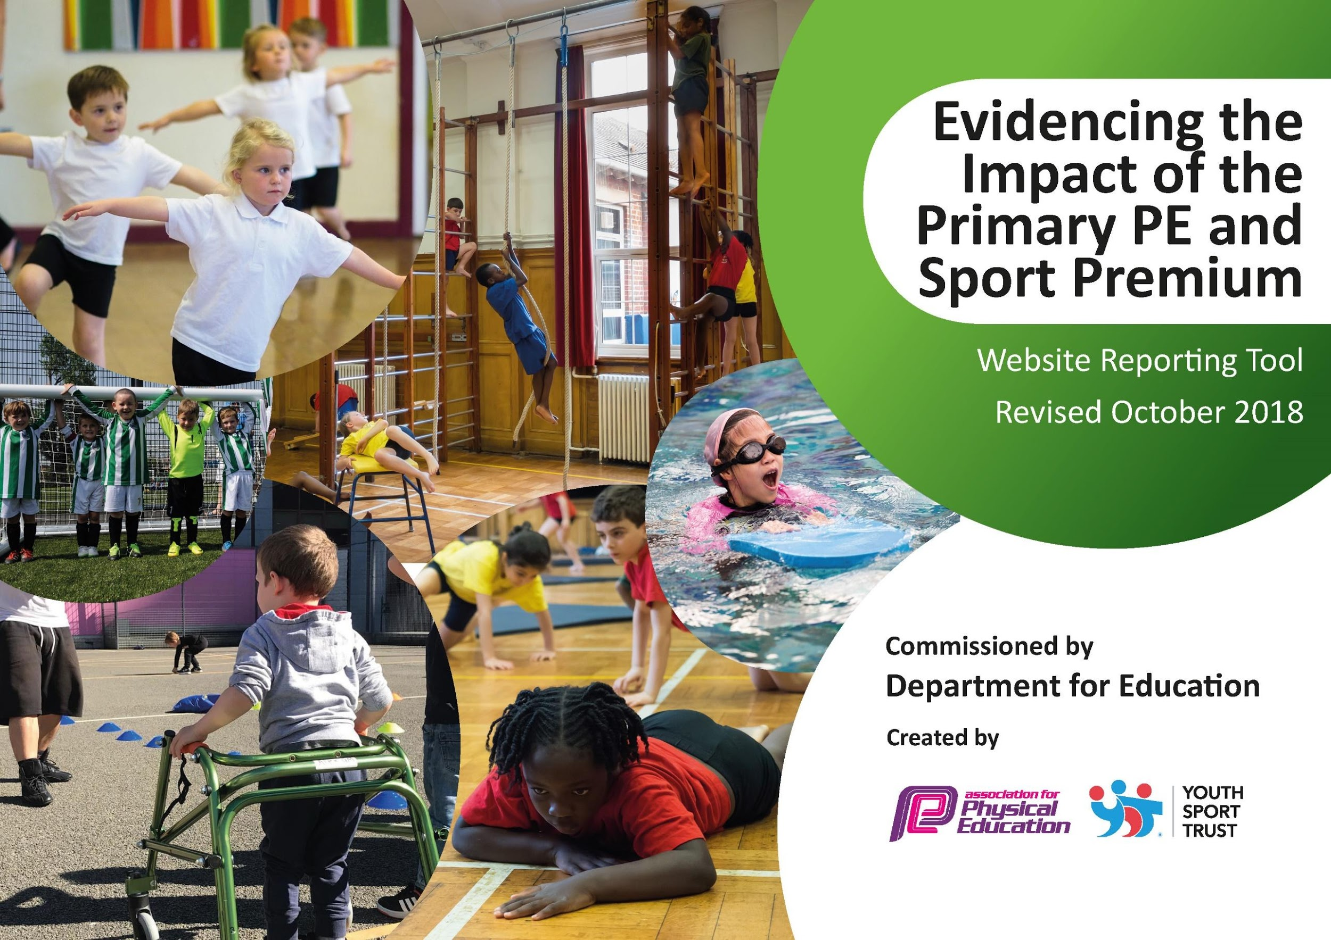
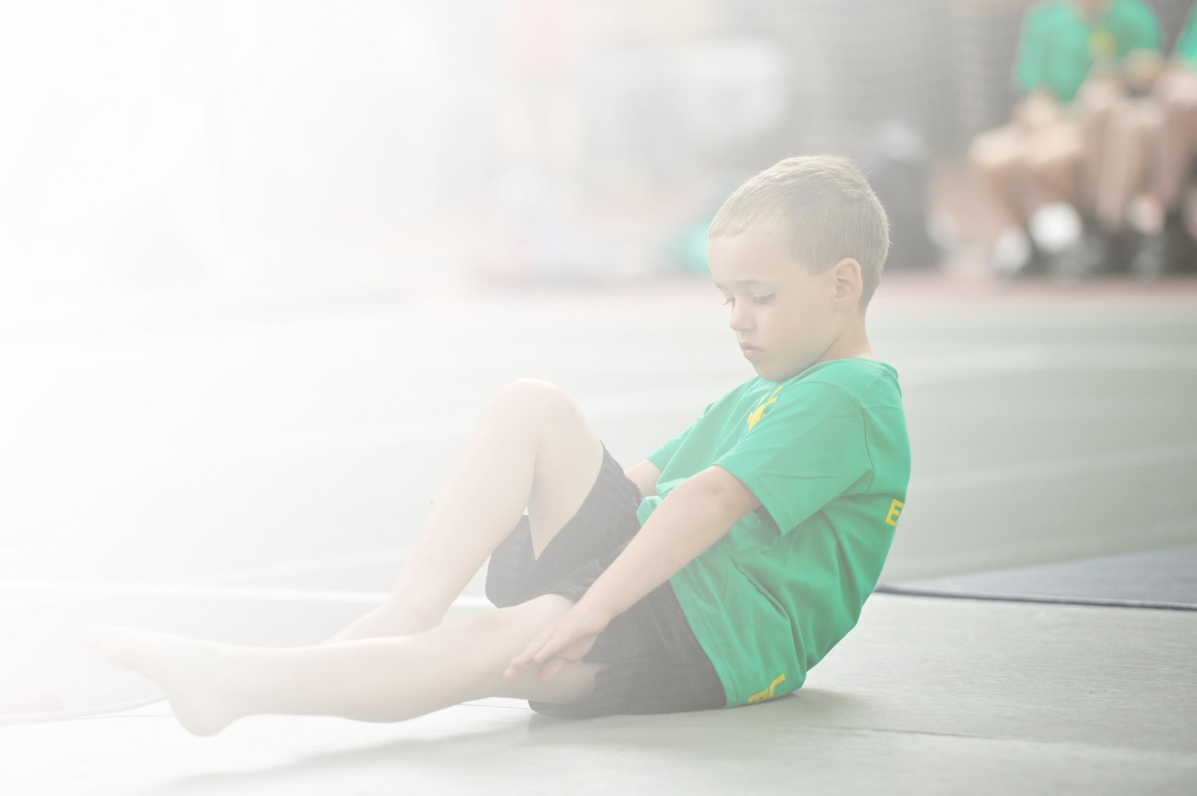
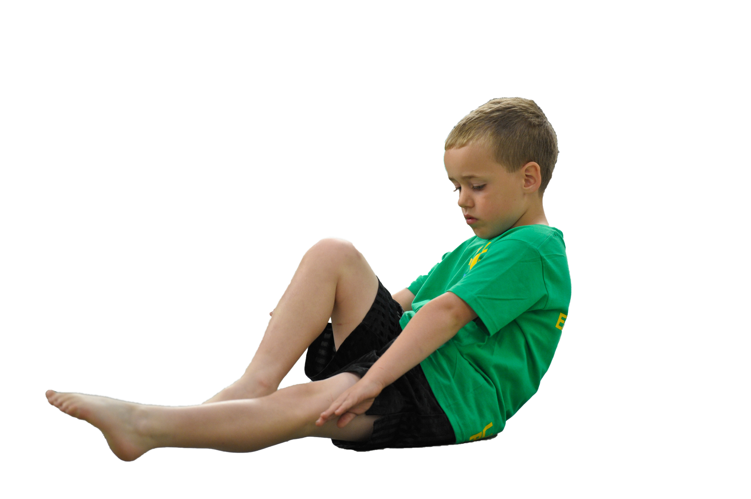
Schools must use the funding to make additional and sustainable improvements to the quality of Physical Education, Sport and Physical Activity (PESPA) they offer. This means that you should use the Primary PE and Sport Premium to:

- Develop or add to the PESPA activities that your school already offer
- Build capacity and capability within the school to ensure that improvements made now will benefit pupils joining the school in future years

Please visit gov.uk for the revised DfE guidance including the 5 key indicators across which schools should demonstrate an improvement. This document will help you to review your provision and to report
your spend. DfE encourages schools to use this template as an effective way of meeting the reporting requirements of the Primary PE and Sport Premium.

We recommend you start by reflecting on the impact of current provision and reviewing the previous
spend. Under the Ofsted Schools Inspection Framework, inspectors will assess how effectively leaders use the Primary PE and Sport Premium and measure its impact on outcomes for pupils, and how effectively governors hold them to account for this.

Schools are required to publish details of how they spend this funding as well as on the impact it has on pupils’ PE and sport participation and attainment by the end of the summer term or by 31 July 2019 at the
latest.
We recommend regularly updating the table and publishing it
on your website throughout the year, as evidence of your
ongoing review into how you are using the money to
secure maximum, sustainable impact. To see an
example of how to complete the table please
click HERE.

Support for review and reflection - considering the 5 key indicators from DfE, what development needs are a priority for your setting and your students now and why? Use the space below to reflect on previous spend, identify current need and priorities for the future.

Key achievements to date: | Areas for further improvement and baseline evidence of need:
- Children have received high quality gymnastics in KS1 from a level 3 gymnastics coach  - Staff have had the opportunity to team teach and be mentored alongside Ebor specialist coach  - Large number of extra curricular clubs have happened on a regular basis  - The school is involved in competitive sports  - PE is embedded into the weekly timetable and children are enthusiastic towards the subject  - Children have access to swimming each week  - Children benefited from a trip to Old Trafford to watch professional football  - Year 6 took part in an outdoor adventure week | - Additional clubs in KS1are needed to provide more opportunities to be active from a young age and hopefully inspire into KS2 and adulthood  - Gymnastics has been a real highlight this year in developing physically literate children; more displays to showcase talent to parents would be welcomed which will allow pupils to build their confidence and build links within the local community.  - More varied active 30 incentives need to be trialled. Some have proven more popular than others; we need to look at what children want, staff can manage and what is the most sustainable.  - Our playleader model needs to be developed. A model was trialled this year but we would like to build on this next year so that it is more sustainable and can run smoothly.  - We want to ensure swimming data rises significantly

Meeting national curriculum requirements for swimming and water safety | Please complete all of the below:
What percentage of your current Year 6 cohort swim competently, confidently and proficiently over a distance of at least 25 metres?  N.B. Even though your children may swim in another year please report on their attainment on leaving  primary school. | 54%
What percentage of your current Year 6 cohort use a range of strokes effectively [for example, front crawl, backstroke and breaststroke]? | 54%
What percentage of your current Year 6 cohort perform safe self-rescue in different water-based situations? | 100%
Schools can choose to use the Primary PE and Sport Premium to provide additional provision for swimming but this must be for activity over and above the national curriculum requirements. Have you used it in this way? | Yes/No

Action Plan and Budget Tracking
Capture your intended annual spend against the 5 key indicators. Clarify the success criteria and evidence of impact that you intend to measure to evaluate for students today and for the future.

Academic Year: 2018/19 | Total fund allocated: £19,300 | Date Updated: 10.07.19
Key indicator 1: The engagement of all pupils in regular physical activity – Chief Medical Officer guidelines recommend that primary school children undertake at least 30 minutes of physical activity a day in school |  |  |  | Percentage of total allocation:
 |  |  |  | %
School focus with clarity on intended impact on pupils: | Actions to achieve: | Funding allocated: | Evidence and impact: | Sustainability and suggested next steps:
- We would like to introduce regular play leaders on a break and lunchtime at Braeburn. This will give pupils more opportunity to be active on a breaktime by providing them with a wide range of activities that they can take part in. This will cut down on levels of inactivity, help improve low level behaviour problems and also raise pupils engagement in class. As Well as all of the above, this programme will also provide our pupils with some leadership roles and responsibilities. | - Look at play leader schemes and see which would best fit our school.  - Open up the opportunity for pupils to apply, through a whole school assembly.  - Identify pupils who want to take part in the programme and inform them. | £307 | - In October/November 2018, Y5 play leaders were notified of a successful place on the scheme.  - Play Leaders were provided with extra curricular training; some in the classroom and some outdoors.  - Play Leaders were deployed onto play duties from December 2018.  - Play Leaders were monitored and feedback taken after the term  - Although this did have a positive impact (through observation) we feel it could have more of an impact next year. | - We must continue to evaluate the programme to make sure that it is working. This will be achieved by speaking to staff, pupils and play leaders.  - Feedback from children suggests that they found it tricky to deal with low level behaviour from peers. To tackle this next year, the profile of play leaders will be raised through assemblies and staff training so that y  they have full support.
2) Bluetooth Speakers - Aimed to get more children active at break times on the playground.  3) Markings for the daily mile to introduce more physical activity into the school day to improve pupils’ health and resilience.  4) basket balls in playground along with nets to enable more opportunity at break and lunch time for physical activity.  5) Gymnastics mats have been identified as no longer fit for purpose and need replacing in order for pupils to take part in a broad curriculum and add to meeting their target of daily physical activity. | - Source best deal for the speakers on the internet  - Speak to office and order  - Speak with caretaker to source quotes  - Caretaker to arrange markings to go down  order nets and get caretaker to erect.  Source quotes to find the best value for the school. | £200  £250  £76.99  £700 | - Year 6 children are now involved in leading dancing sessions on the playground. 6 year 6 play leaders leading sessions with any number between 5 and 20 children each playtime.  - Active mile markings went down in Autumn 2 and as a result they have been used daily.  - The children have gained stamina for running more than one lap. They talk about wanting to do more laps. In KS1 PE lessons we have talked about personal best and trying to improve.  These are now in use on a daily basis and have seemed to have a really positive impact (through observation) one child said “we love playing basketball with Mrs Greenly at lunchtime”  New mats ordered and more floor work has now been added to the curriculum map.  Pupils have the opportunity to further enhance their movement, creativity and physical activity | - Constant use of equipment throughout school not just playtimes is an option.We need to make staff/pupils aware of dance groups on the playground.  - We have recognised that this incentive needs to continue and any issues discussed with staff to make sure that children and staff enjoy the activity. Possible links with maths could be introduced once established.  If possible use in PE lessons so more children have the opportunity to experience and possibly enjoy a new sport.  Look at how these will be stored and embedded into the curriculum next year.
Key indicator 2: The profile of PESSPA being raised across the school as a tool for whole school improvement |  |  |  | Percentage of total allocation:
 |  |  |  | %
School focus with clarity on intended impact on pupils: | Actions to achieve: | Funding allocated: | Evidence and impact: | Sustainability and suggested next steps:
Inspirational visitor to raise the profile of sport and physical activity.  Introduce active 30 to school.  Additional visitor/Coach  Increase number of children able to swim 25 meters. | organise visitor via sports for schools  ask for staff meeting time to deliver this  Ask local Gymnastics club for a team GB gymnast to visit school  consult with swimming coach about resources that will support this. | Nil  Nil  Nil  £1250 | All children took part in a circuit with Jenny Wallwalk and James Curtain, followed by an inspirational assembly.  “what a fantastic opportunity for children to see and experience first hand world class athletes, exercising alongside them, hearing about their personal journey and asking them questions.”  On 12th February staff we giving information about active 30, a variety of websites for ideas was shared and a daily record sheet to record what activities were being done in each class.  Megan Coates a local gymnast who has represented team GB came into school and supported PE lessons and delivered 4 after school clubs.  A large amount of resources have been ordered to support a swimming programme which we hope will see a rise in swimming attainment. This has allowed us to put a programme of swimming in place to support all children right through school. We are now in a position to offer free extra curricular swimming lessons as a result of this. | Organise other visitors whenever possible and invite a sport for schools athlete every other year.  Most classes are managing to fit additional physical activities into their day. The next step would be to remind staff and provide a new record sheet for the summer term.  As the visit was just after half term the uptake on the club was not good, parents failed to return consent forms. In future organise visitors not just after a holiday and try online consent forms.  Maintain the swimming resources and have an assessment system that helps us meet the needs of children.

Key indicator 3: Increased confidence, knowledge and skills of all staff in teaching PE and sport |  |  |  | Percentage of total allocation:
 |  |  |  | %
School focus with clarity on intended  impact on pupils: | Actions to achieve: | Funding  allocated: | Evidence and impact: | Sustainability and suggested  next steps:
- KS1 staff would like the opportunity to learn some new games ideas. By using our local cricket organisation “ Chance To Shine, staff will get to team teach alongside and gain ideas.  PE Specialist | - Email the coach to check availability and book in when appropriate | £75  £2000 | - In Spring 2/Summer 1, Chance To Shine came into Braeburn on a Friday to deliver lessons alongside the class teacher.  - On the 13.5.19, pupils attended a local cricket festival for the first ever time. One child said “ It was so cool going on the bus and playing games with the children, I loved it”  Working alongside existing staff to support in planning and delivering a variety of different sports.  Introducing systems for assessing children's ability in PE and participation in extracurricular sports. | - Using the knowledge gained from the coaches sessions, staff will have the opportunity to deliver striking and field games in Summer 2 with their classes based on what they have seen.  - Staff will also have access to planning and resources from the Chance to SHine website portal and free login details.  - This will continue next year too.  Gareth's support has been valuable. To provide real long term sustainability it would be beneficial if he could work with more members of teaching staff. To upskill them and provide support with assessment and differentiation.
Key indicator 4: Broader experience of a range of sports and activities offered to all pupils |  |  |  | Percentage of total allocation:
 |  |  |  | %
School focus with clarity on intended  impact on pupils: | Actions to achieve: | Funding  allocated: | Evidence and impact: | Sustainability and suggested  next steps:
We would like to Introduce Table tennis into school as a dinner time and afterschool club. Pupils have never tried this before so we would like to broaden their opportunity. | - Source best deal for the school in buying the tables  - Put purchase order in and order equipment | £400 | - Equipment arrived in Autumn 2  - The first month of trying the scheme (January) 10 children every dinner time attended using the tables. 20% of KS2  “Table tennis is awesome” | - We would like to try taking one of the tables in KS1 dinner time club.  - Seek out any schools to invite and potentially start competitive Table Tennis.  - Have a table tennis committee/team  - Enter Scarborough School Sports Competition is a long term plan.
We would like to give our KS1 pupils the opportunity to try a different form of physical activity. We have been recommended Local Yoga and pilates teacher (Ricky Stewart) which will give our pupils in KS1 that opportunity. | - Subject Leader to set times and dates with management and Ricky Stewart (coach)  - Make staff aware | £35 per session  £70 total | Starfish class on 1st July 2:15-3  Seals 2:15-3 | Starfish children thoroughly enjoyed the experience. One parent commented on class dojo”Ryeland loved spiderman” she also asked me where her invite was. I informed her that there is a possibility that we may hold parent and child sessions after school in the future.
When we reviewed our curriculum offer, we noticed that there is limited opportunity for pupils to take part in certain activities; one of which was hockey. By introducing hockey equipment, it will allow pupils to broaden their skill set. | order in preparation | £1000 | Over 180 pupils have benefitted from new hockey equipment and have commented on how much they enjoy using this. It has also had an impact on behaviour by having a better ratio of equipment; staff have noticed pupils are more engaged. | We want to look at entering pupils into competative hockey fixtures after continuing to embed hockey in the curriculum next year.
Key indicator 5: Increased participation in competitive sport |  |  |  | Percentage of total allocation:
 |  |  |  | %
School focus with clarity on intended  impact on pupils: | Actions to achieve: | Funding  allocated: | Evidence and impact: | Sustainability and suggested  next steps:
By having a Level3 gymnast coach in school who is employed as a HLTA, we want to utilise her expertease and deliver more high quality gymnastics to pupils. To support this we have identified equipment which would be needed thus hopefully developing pupils movement skills and creating more physically literate children at Braeburn. | - Subject Leader to speak to gymnast coach about best equipment to have an impact.  - Get approval from SL Tand order equipment | £1500 | The equipment arrived during the Easter holidays and is ready for the Autumn term.  Our Gym coach said “Our reception children were first to use the new equipment and loved bouncing off the new trampet, making shooting stars and balancing on the beam pretending to be tightrope walkers in a circus!” | - Equipment will be used yearly during lessons  - Gym club will be setup in preparation for the local inter schools gymnastics competition.  - Equipment to be looked after and maintained so that it is safe to use.
We would like more Braeburn pupils to take part in athletics competitions and to do that we require equipment to assist. We intend on using athletics to help build pupil’s physical skills and also their personal skills, such as; resilience, determination, sportsmanship and aiming for personal bests. | - Subject Leader to look in YPO at appropriate equipment and source the internet.  - Choose equipment and get approval from SLT and order | £1890 | - Equipment arrived in April  - The equipment has been used one lunchtime per week for an extracurricular club. Over the course of an hour nearly 50 children are observed to take part in activities.  - Aswell as more children being physically active, they are trying new activities. The subject leader has commented that children are very excited when they see the athletics equipment and it is obvious that there is a real desire to take part.  - Some EYFS pupils have already started to take part which is looking positive for future years and inspiring Braeburn pupils. | - Equipment will be used during lessons, athletics club and prep for the inter schools athletics competition  - Braeburn has registered to take part in a quad kids competition  - Subject Leader has created a unit of work to share with staff for sustainability.

